Packet Tracer – Connect and Monitor IoT Devices

The Smart Home Network

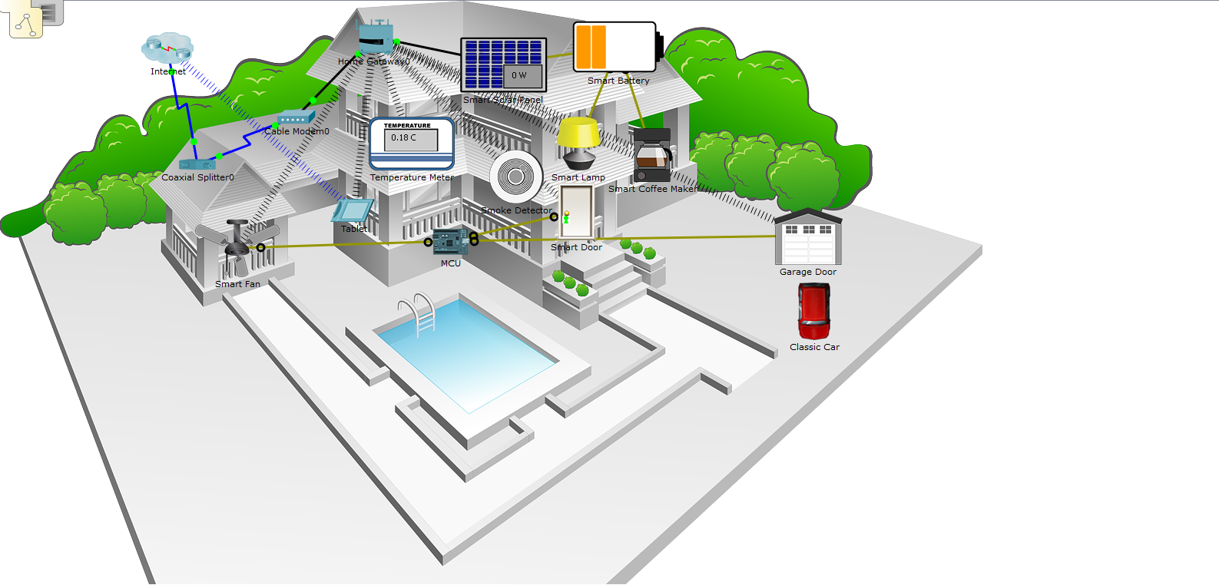

1. Objectives

Part 1: Add Home Gateway to the Network

Part 2: Connect IoT Devices to the Wireless Network

Part 3: Add End User Device to the Network

1. Background / Scenario

In this activity you will add a Home Gateway and several IoTdevices to an existing home network and monitor those devices through the Home Gateway.

1. Connect a Home Gateway to the Network
   1. **Open the Smart_Home.pkt file and save the file to your computer**

**Step 1: Adding a home gateway**

* + - 1. Select the Home Gateway device.

Click the **Wireless Devices** icon in the **Device-Type Selection** box. Click the **Home Gateway** device icon and then click in the Logical workspace to add the device.

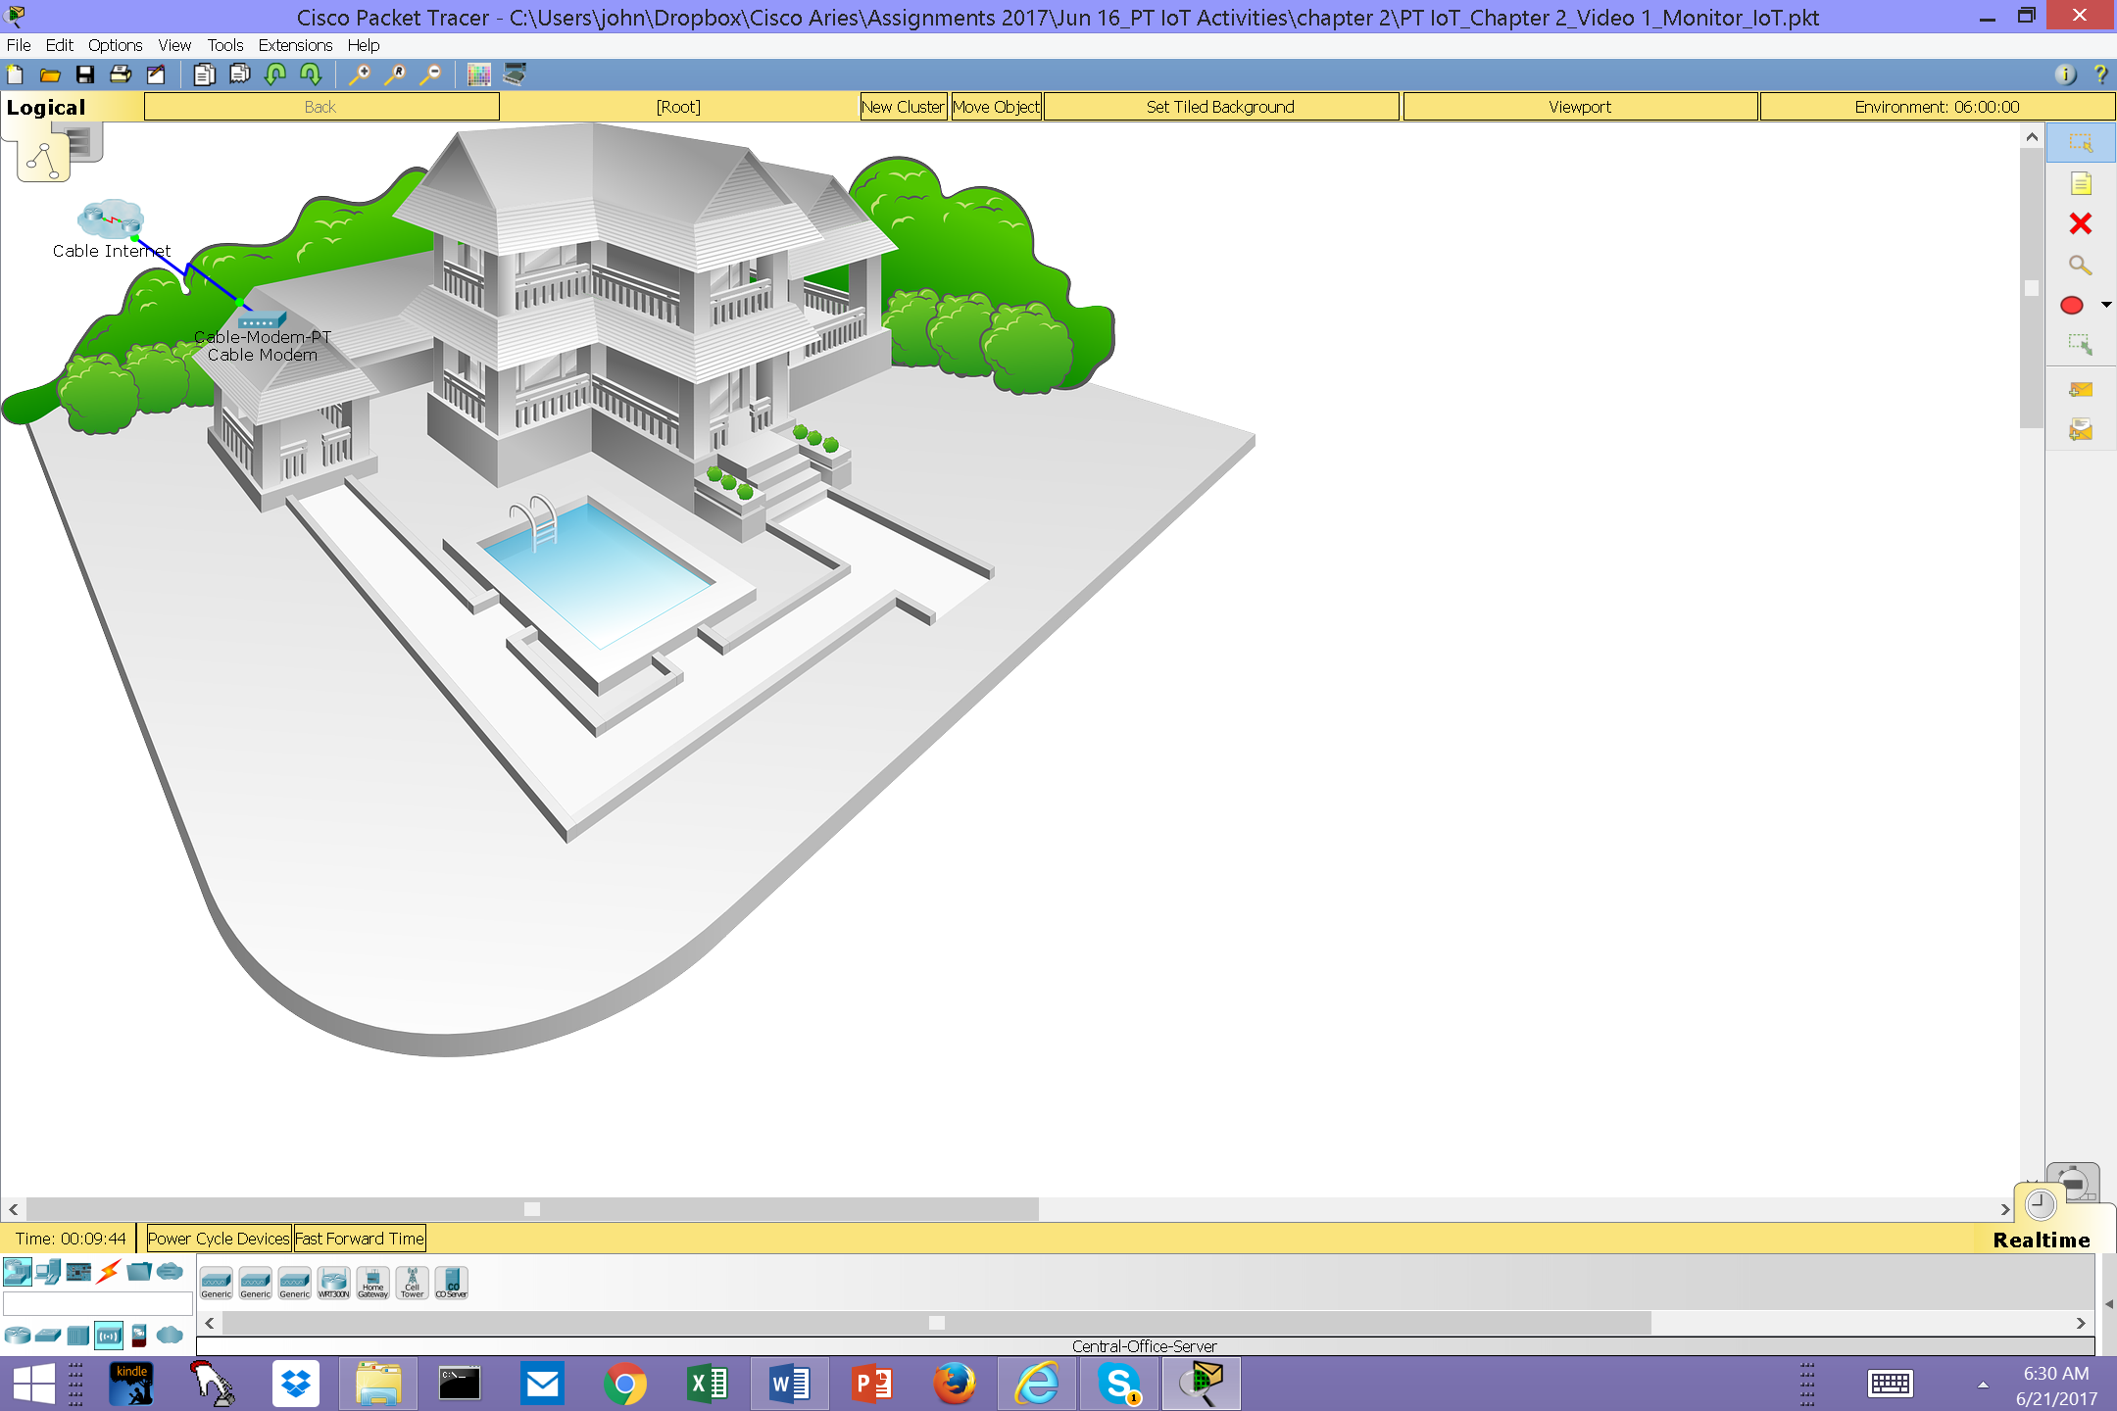

* + - 1. Connect the Home Gateway to the Cable Modem.

Click the **Copper Straight-Through** connector icon in the Device-Type Selection box, then click the Home Gateway to add one end of the cable to the gateway. Next, click the Cable Modem icon to connect the other end of the cable to the **Internet** port.

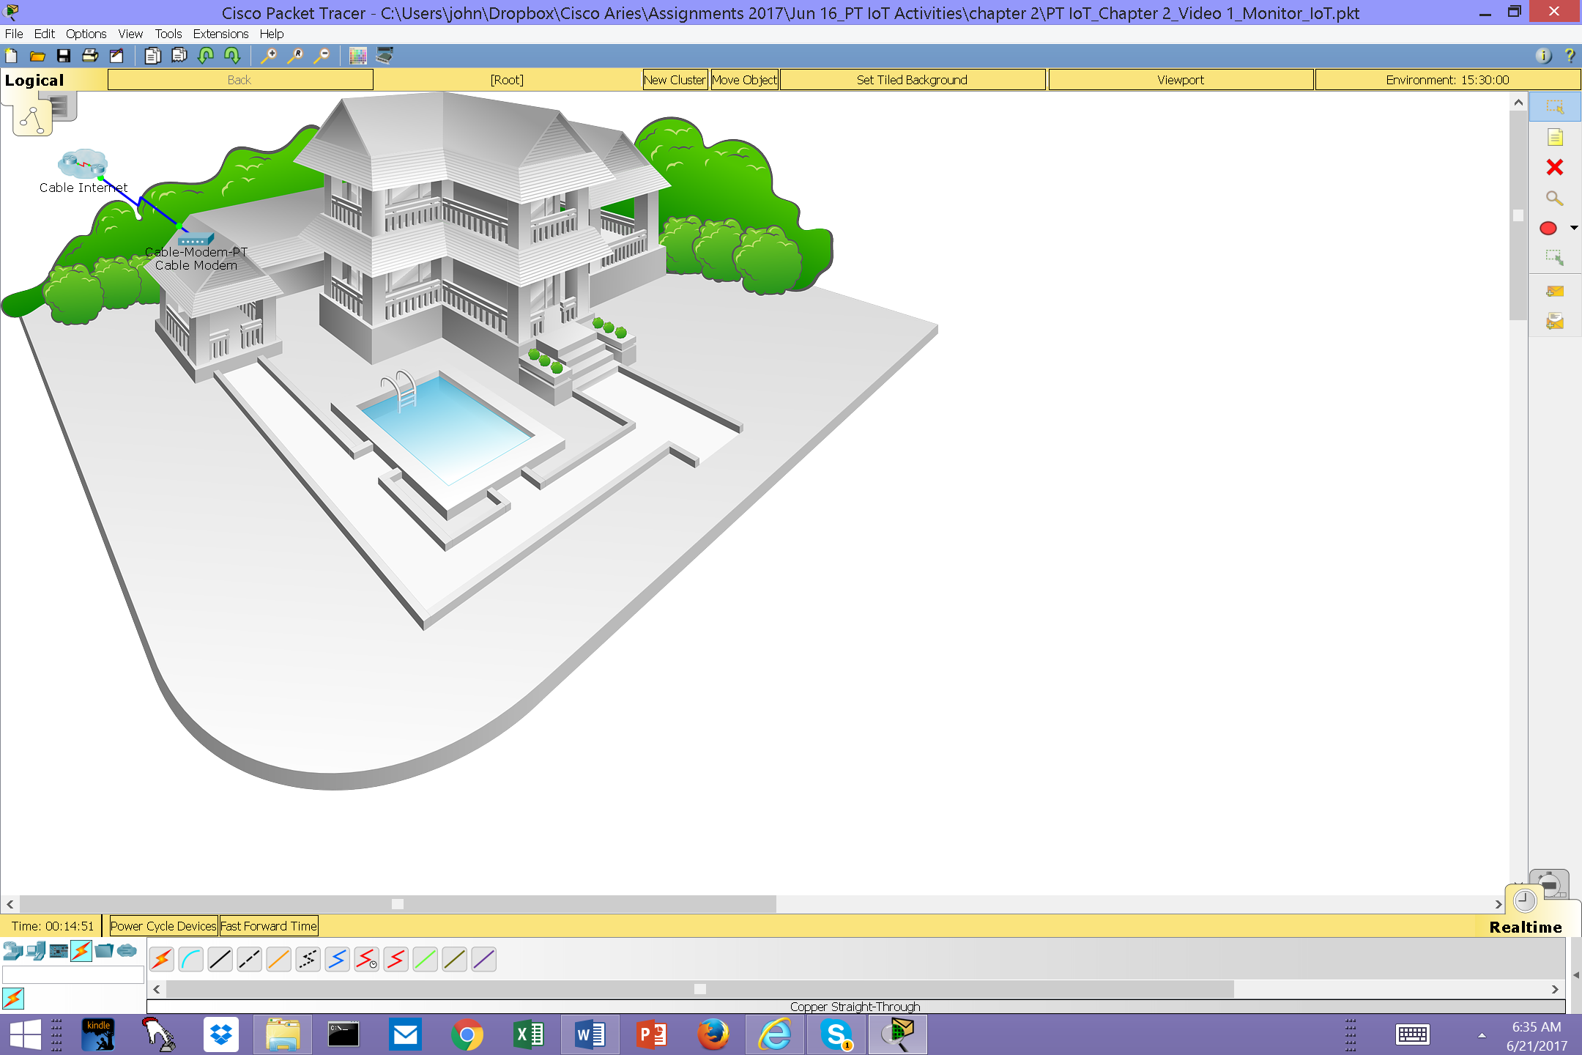

After a few seconds both ends of the cable should have green lights indicating that the link is up.

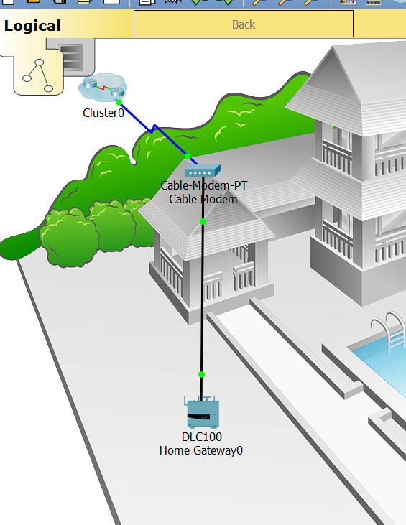

1. Connect IoT Devices to the Wireless Network

Step 1: Select wireless devices

* + - 1. Click the **Home Devices** icon in the **Device-Type Selection** box and add the **Fan,** the **Door,** and the **Lamp** to the workspace.

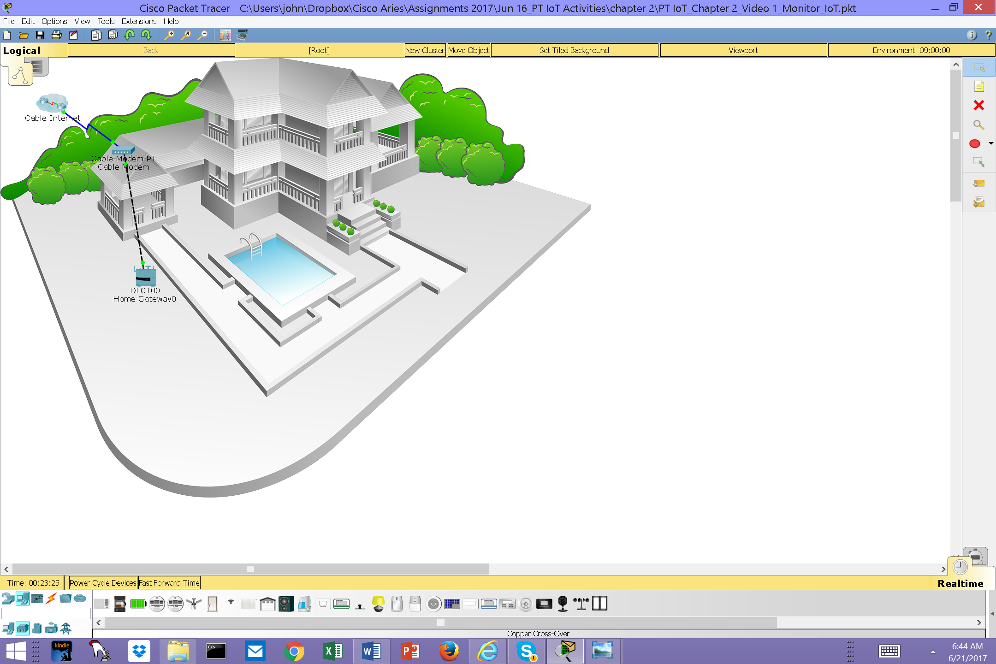

Step 2: Add devices to the home wireless network

* + - 1. Add a wireless adapter to the **Fan** device.

Click the **Fan** icon in the workspace to open the **Config** tab and then click the **Advanced** button in the bottom right corner of the window. Notice that the tabs at the top of the configuration window change. There are now more tabs.

Click the **I/O Config** tab and change the **Network Adapter** type to the **PT-IOT-NM-1W** wireless adapter.

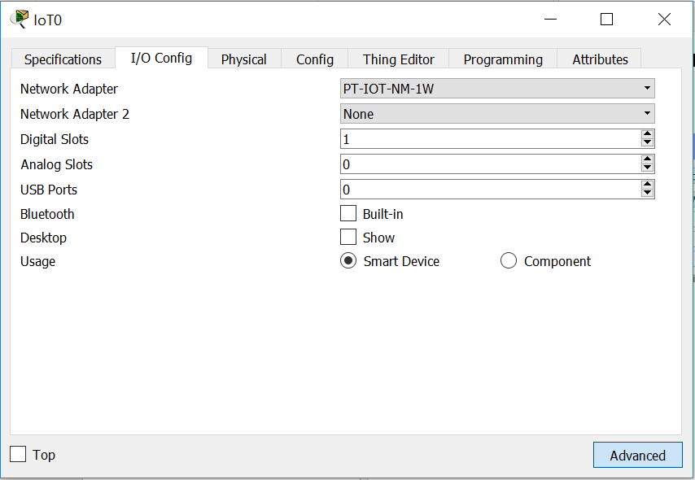

* + - 1. Change the display name of the **Fan** device.

Click the **Config** tab. In the Display Name box, type **Ceiling Fan**.

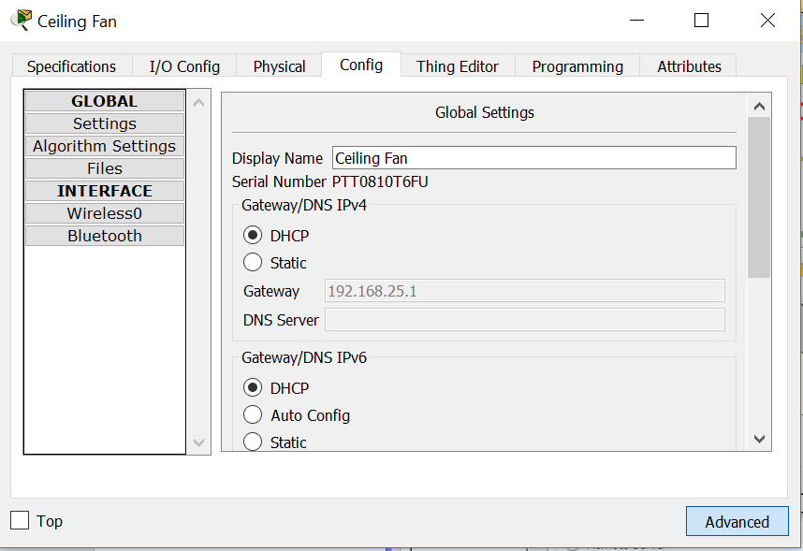

* + - 1. Verify that the Fan device is connected to the wireless network.

While still in the **Config** tab, click the **Wireless0** interface in the left pane.

In the configuration settings, the **HomeGateway** network should be listed in the SSID box. Verify that the DHCP is selected in the **IP Configuration** settings, the IP address is 192.168.25.100 and the default gateway is 192.168.25.1. This indicates that the fan is connected to the network and is receiving IP configuration information from the home gateway.

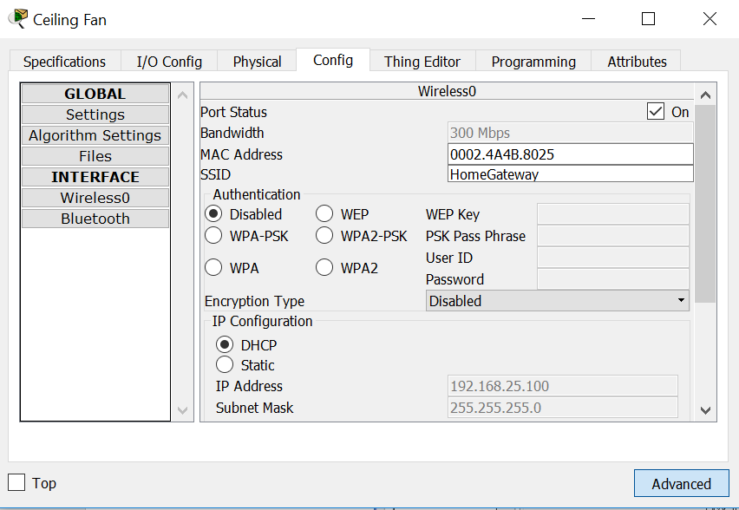

Close the Ceiling Fan configuration window.

* + - 1. Connect the **Door** and the **Lamp** to the wireless network following the same steps used for the fan.

1. Add a Wireless Tablet to the Network

Step 1: Add the wireless tablet to the workspace

* + - 1. Click the **End Devices** icon in the **Device-Type Selection** box and add the **Wireless Tablet** to the workspace.

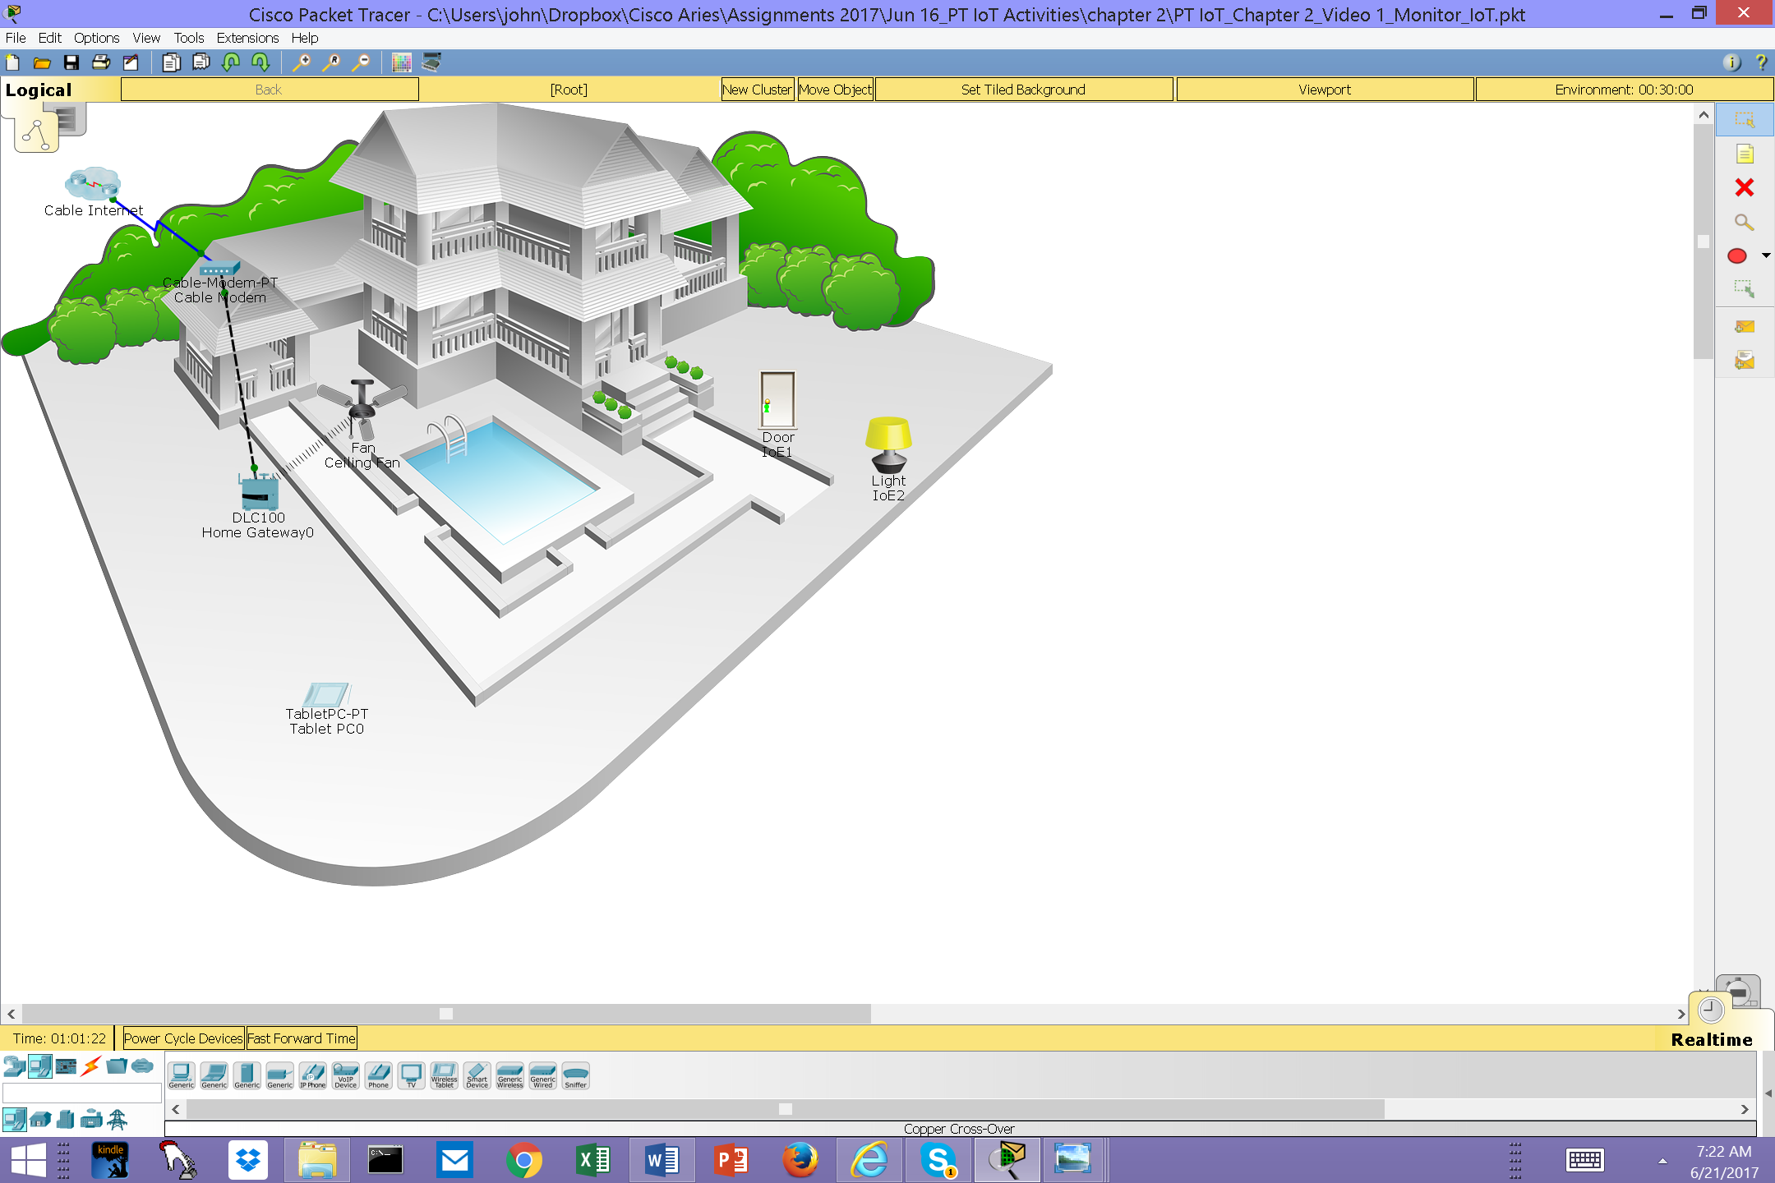

Step 2: Connect the wireless tablet to the HomeGateway network

* + - 1. Change the wireless tablet network settings.

Click the **Tablet icon** to open the Tablet configuration window.

Click the **Config** tab and then click the **Wireless0** Interface. Change the SSID from **Default** to **HomeGateway**. After the network SSID is changed the Tablet should learn an IP address through DHCP within a few seconds.

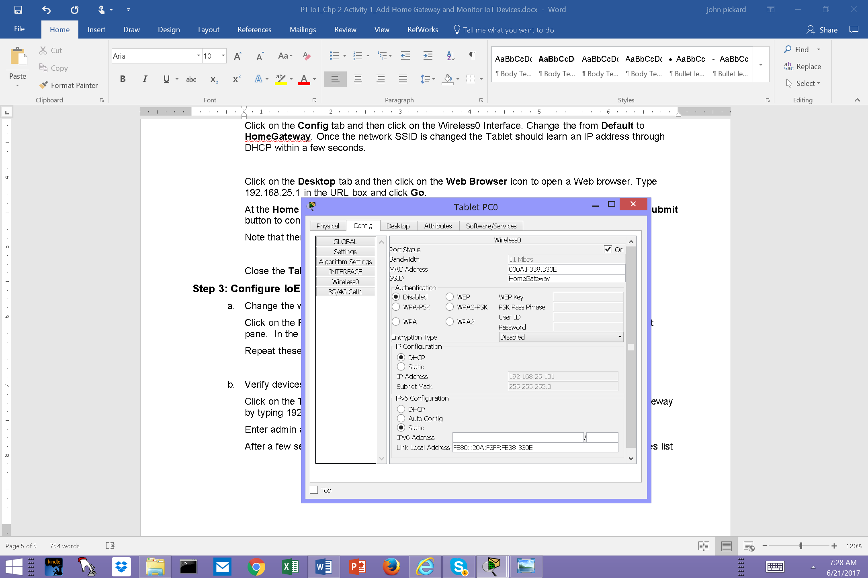

* + - 1. Access the home gateway IoT server from the tablet.

Click the **Desktop** tab and then click the **Web Browser** icon to open a Web browser. Type192.168.25.1 (the address of the home gateway) in the URL box and click **Go**.

At the **Home Gateway Login** page, enter **admin** as the username and **admin** as the password and click the **Submit** button to connect to the Home Gateway server.

Note that no devices appear in the Home Gateway IoT Server - Devices list.

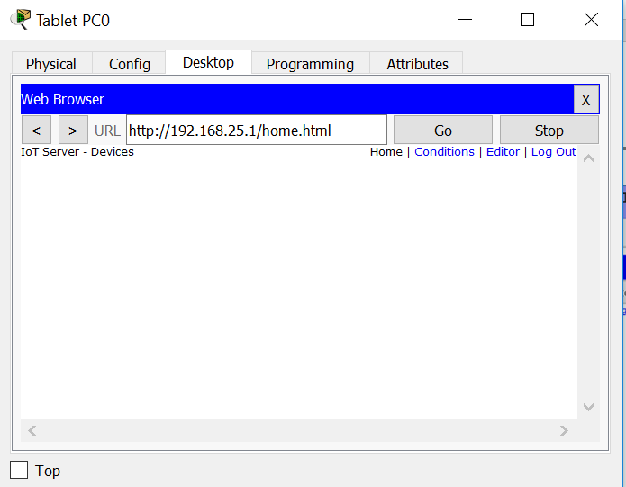

Close the **Tablet** window.

Step 3: Configure IoT devices to register with the Home Gateway server

* + - 1. Register the ceiling fan to the home gateway server.

Click the **Fan** icon in the workspace, click the **Config** tab, and then click **Settings** in the left pane. At the **IoT Server** options list, click the **Home Gateway** button.

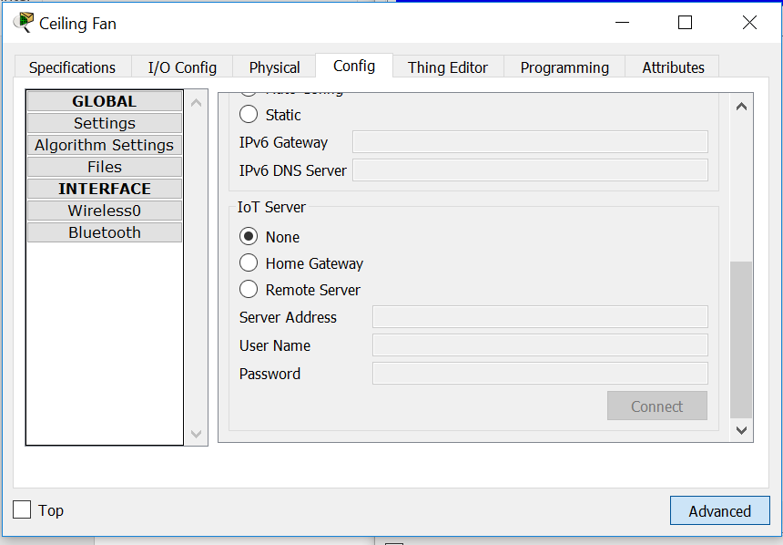

Close the **Ceiling Fan** window.

Repeat the steps in 3a to register the **Door** and the **Lamp** devices to the home gateway.

* + - 1. Verify that the devices are now registered with the Home Gateway server.

Click the **Tablet** icon in the workspace and open the **Web Browser**. Connect to the Home Gateway by typing **192.168.25.1** in the URL box and then click **Go**. Enter **admin** as the username and password and click **Submit**.

After a few seconds all three devices should be listed in the Home Gateway **IoT Server - Devices** list.

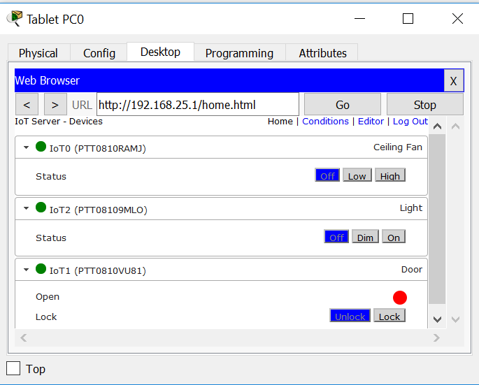

Close the **Tablet** window.